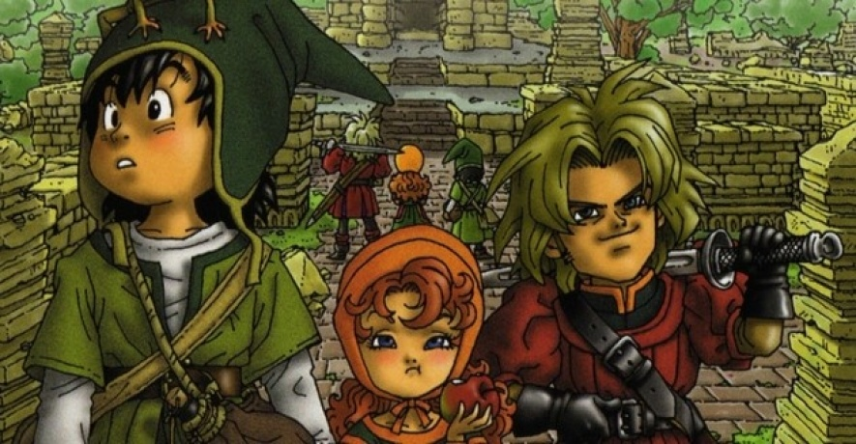I’ve loved the Dragon Quest games since I was little. One of the first games I ever played, after Mario Bros. for Nintendo, was Dragon Warrior. It came for Christmas, with a save game already saved in it. My Dad told me that Santa’s elves had been playing it. I accepted this. Who wouldn’t want to play?

Fast forward 25 years to the 3DS remake of Dragon Quest 7 – Dragon Quest 7: Fragments of the Forgotten Past.

This game originally came out in in the year 2000 for Playstation. Does the game hold up? Simple answer: yes.

The story is one of the most epic of all of the Dragon Quest games. You start in a small fishing village, on a small island. The only island in the entire world. You are the son of the greatest fisherman alive, and best friends with the rascally prince Kiefer of the Kingdom. His name now makes me hungry for tasty yogurt drinks.

You two are friends with the Maribel, daughter of the mayor, who spends the first half of the game being rude and unlikeable. You’ll notice that in the picture above, she’s kind of scowling. Ugh. Hate her. At least in the beginning.

The three of you form a party of bored teenagers who just *know* that there’s something else out there in the world beyond your boring little island kingdom.

Except there isn’t. You can clearly see on the world map that you’re alone in the world. Everyone you talk to in town agrees – there’s nothing else out there! Your fishing fleet has sailed all around the world hundreds of times, and never encountered anything else.

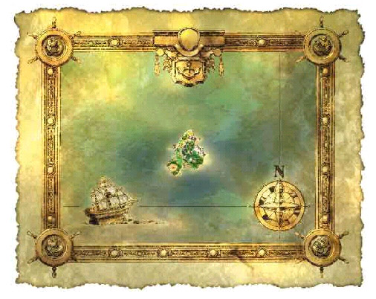

Ah well. Doomed to boredom for life, I suppose. But that doesn’t stop your princely friend. He drags you along to explore the ruins on the side of the island, which your overprotective parents and townsfolk warn you not to do. The game alludes multiple times to deadly man-eating bears that roam the “eastern hills,” but those never appeared in my game. And I looked around for them, too! I was hoping that Square-Enix had included some battle possibilities on the home island. In the original game, the island was totally peaceful. No combat, no monsters.

I guess the remake was supposed to have bears to sink your copper sword and bamboo spears into. It doesn’t appear to. Given, I’m only about 6 hours into the game, so maybe they appear later.

Overall, the introduction to the game has been streamlined. It used to be an hours-long slog through town, back and forth to the ruins, before you finally figured out that other islands had been somehow sealed away, and that you could “unseal” them, bringing them back into the world.

Now it takes about an hour. Which is still a long time by the standards of these days. An entire hour in a Dragon Quest game without a single fight? I could see how this would be a huge turnoff to your average RPG player. Even someone who loves Dragon Quest games.

But the game really takes off immediately after this. You are sucked into a world, cloaked in darkness, filled with dread. The town you encounter is doomed, with all of the town’s women having been captured by monsters. Your characters, ill-equipped and unleveled, are completely unequal to saving this town. Saving anything, probably. This first island helps you out – giving your two burly companions to help you through battle. This is really cool. Reminiscent of Dragon Quest 5, when little boy Hero gets to party up with his badass Dad Super Hero for a bit.

Anyway, once you save this island, and it reappears in the world, stuff starts to get really weird. In a really good way. There is a rich aura of mystery all around this game, because *nobody has any idea what is happening*. The remake does a great job of helping the suspense along by giving you an impish-fairy creature to help you out. He doesn’t tell you anything useful, or at least, nothing that helps solve the mystery. The adults in the Kingdom immediately have a meeting to determine what has occurred, and what must happen next. You are not invited to this meeting.

I won’t spoil any more of the story, other than the fact the Maribel gets better.

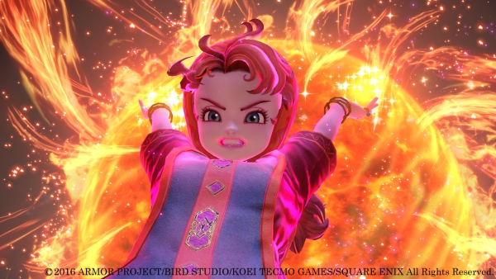

She’s your awesome mage. Once vocations are unlocked, you can technically make anyone in your party a mage, or your entire party if you really want. But she learns offensive spells naturally, without any changes needed.

There is a whole host of characters, and while I’m only about 10 hours into the remake as of this writing, I’m already impressed with how much better the characterization is. Maybe it’s just easier to connect with characters who actually have facial expressions.

Overall, the graphics have been lovingly redone for the 3DS, boasting impressive facial expressions and fun details in every situation. Your hero’s little green cap flops up and down when he runs, stops, and bumps into things. The gameplay has been streamlined in some situations, making it easier to get into the game. Finally, the speed of battle has been increased, which seriously cuts down on the sometimes painful grind of Dragon Quest games. This can be increased even further in the settings.

Does the game hold up? Longer answer: maybe.

Dragon Quest 7: Fragments of the Forgotten Past is a very deep game. Players will easily sink over fifty hours of beating it. If you want to unlock all of the secret vocations and dungeons and bosses, easily over one hundred hours. The beginning of the game is still slow, albeit better than it was originally. If you’re looking for a deep, gripping, mysterious Dragon Quest game, then this is it. Casual lovers of RPGs might want to steer clear.